Final Year Project Proposal



**Efficient Automated Service Provider**

**(EASP)**

**Supervisor**

**Sir Uzair Saeed**

**Submitted by**

**Abdur Rehman** BSCS-FA19-050

**Muhammad Kabeer Khan** BSCS-FA19-061

**Ahmad Jilani** BSCS-FA19-035

**Department of Computer Science**

**The University of Faisalabad, Engineering Wing**

**Faisalabad, Pakistan**

**(**Date of Submission: 08-02-2023)

**Declaration**

This report has been prepared based on my own work. Where other published and unpublished source materials have been used, these have been acknowledged.

Word Count: ___________________________

|  |  |  |  |
| --- | --- | --- | --- |
| Students Name: | Abdur Rehman | Muhammad Kabeer Khan | Ahmad Jilani |
| Student Registration No: | BSCS-FA19-050 | BSCS-FA19-061 | BSCS-FA19-035 |
| Signatures: |  |  |  |

Date of Submission:

Supervisor Name:

Supervisor Signature:

**CERTIFICATE**

We accept the work contained in the proposal titled “**Efficient Automated Service Provider**”, written by Mr. Abdur Rehman, Mr. Kabeer Khan, and Mr. Ahmad Jilani as a confirmation of the required standard for the partial fulfillment of the degree of Bachelor of Science in Computer Science.

Approved by:

Supervisor: Mr. Uzair Saeed

Project Coordinator: Mr. Rehman Shahid

Head of the Department: Dr. Prof Majid Hussain

December 1, 2022**ACKNOWLEDGMENT**

First and foremost, praise Allah the Almighty, the Most Merciful, the Most Gracious, for His showers of blessings throughout our project work to complete the SPEP proposal successfully. Before we begin developing the Proposed System and describing the comprehensive chapters, we want to thank everyone who assisted us at various phases of our project. We boldly state that the project's success is contingent on our parents' unending prayers and support. We would like to express our appreciation to our teachers, who assisted us much in obtaining various information, collecting statistics, and mentoring us from time - to - time in the creation of this project. We would want to express our special thanks to our respected faculty members who offered to assist us in many sections of the problem area. We are grateful to our esteemed teacher, Sir Muhammad Rehman Shahid, for always lending a helping hand in all aspects of the project's development, and especially for enabling us to move forward during the field of developing software products/projects in accordance with internationally recognized standards. We are grateful to Dr. Majid Hussain, HOD and our supervisor Sir Uzair Saeed, for their continued support and for inspiring us to create something unique and new.

Contents

Chapter 1: Introduction 1

1.1 Background 1

1.2 Project Vision 2

1.3 Problem Statement 2

1.4 Objectives 2

1.5 Project Scope 3

1.5.1 Market Competitors 3

1.5.2 Business significance 4

1.5.3 Project Planning 4

1.5.4 Financial Plan 4

1.5.5 Constraints 5

Chapter 2: Software Requirement Specification 6

2.1 List of features 6

2.2 Quality Attributes 6

2.3 Non-Functional Requirements 6

2.4 Methodology 6

Chapter 3: Logical Design and Architecture 8

3.1 Expanded Use Case 8

3.1.1 Description 8

3.2 Activity Diagram 9

3.2.1 Description 10

3.3 Domain Model 11

3.3.1 Description 12

3.4 Architecture Diagram 13

3.4.1 Description 14

3.5 Sequence Diagram 14

3.5.1 Description 15

Chapter 4: Conclusion 16

Bibliography 17

**List of Figures**

Figure 1 Minimum Wages in Pakistan 2

[Figure 2 Use Case Diagram 8](https://pern-my.sharepoint.com/personal/bscs-fa19-061_tuf_edu_pk/Documents/EASP%20Report%20Updataion.docx#_Toc126098974)

Figure 3 Activity Diagram 9

Figure 4 Domain Model 11

Figure 5 Architecture Diagram 13

Figure 6 Sequence Diagram 14

**List of Tables**

Table 1 Market Competitors vs EASP 3

Table 2 Gantt Chart 4

Table 3 Financial projection 5

# Chapter 1: Introduction

As technology evolves and the world moves with it, in Pakistan we don’t see such evolution in this space, as we are not giving chances to the skillful laborers with low wages to express their skill set for better income. This app will help them to become common or become known to the public. Through our app service seekers will we be able to connect with these people. Our vision is to facilitate people and businesses in outsourcing their work; whether you're seeking employment or want a worker to carry out a specific task, we can assist you in finding the best match. As a Pakistani who understands people that are service providers and service seekers, I think this app will perform well for middle-class people. And I can sense a bright future in this domain because in middle-class families there’s always been an issue to find a person who can do their chores and daily routine household tasks. As a lazy person, I can present all lazy people and can assure you that one will prefer to find a service provider online rather than going out and wasting his time and money. So, this project is a step in this direction that can impact multiple lives and can have better outcomes.

## Background

Being extremely lazy in every aspect of life I have always preferred some convenience of some sort. But one day the idea came to my mind that there are many convenience apps nowadays that are very helpful to my type of audience, so I did some research and found some apps that I thought can help me with my chores. Still, I was disappointed that I found none of them that have diverse options of services. So as a developer, I gave myself a challenge for myself and other people like me, and I think through my effort I can provide a platform to the people who still have no privilege of giving their services online. Following is the list of monthly income of Pakistani’s.

In the past many years there’s been only number of applications that are service providing in multiple domains such as Supertasker, Maher, Services Finder etc. each with its own unique features and limitations. Some of them are company-based applications while supertasker is a gig-based application where one can post a task and one with reasonable experience can offer him his services. But these apps are mostly dead in a way that they are not marketing their applications hence no reach of public toward their apps.

This motivated us in first place and now we are going making this webapp that will resolve all the problems that the other apps had in the past and we will try to overcome their existing problems and will make a better app that hopefully will be the only app in its domain that will dominate.

(Wage Indicator, 2019)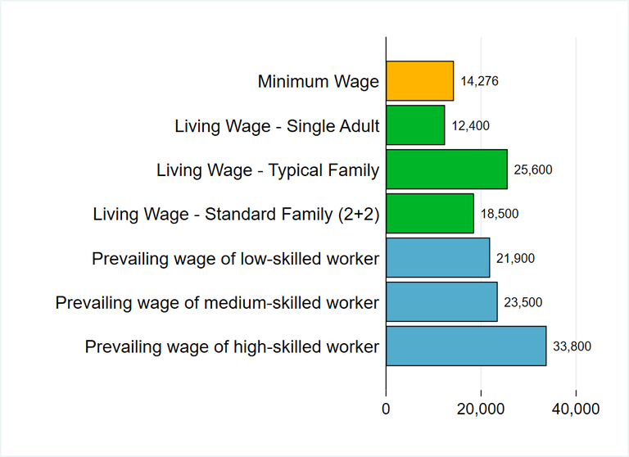

Figure Minimum Wages in Pakistan

## Project Vision

The vision of this project is to have a better relationship between service provider and service seeker. And our main goal will be to close the gap between these two entities. And we want a far better outcome as we want our skilled laborer community to have some exposure to a broader audience that will add some additional value to his income and will improve our poverty rate that is going fast as time is passing.

## Problem Statement

In Pakistan, more than two million individuals have slipped into poverty. Using the lower-middle-income poverty rate ($3.2 per day), the World Bank calculated that Pakistan's poverty rate was 39.3 per cent in 2020-21, 39.2 per cent in 2021-22, and 37.9 per cent in 2022-23. (Word Bank, 2022) And most of them are some sort of service providers like motor mechanics, gardeners, plumbers, maids, servants, etc. and there is no platform for them to list their offerings. That is why we will provide a platform for service providers and the one who seeks, where every type of service provider can list his offerings without any restrictions.

## Objectives

Our vision is to facilitate people and businesses in outsourcing their work; whether you're seeking employment or want a worker to carry out a specific task, we can assist you in finding the best match. Skilled people may make extra money using our website.

The key features of our project are:

* There will be no constraint on the type of service that can be found on the platform.
* The user can be both provider and seeker simultaneously.
* Rank and update service providers with users' new tasks that are located within a 5-kilometer distance around them.
* Users and service providers can negotiate a price.
* Service provider lists his specialty along with prices.
* There may or might not be a delivery charge (totally depends on the service provider).
* The website will allow you to communicate with the service provider.
* Users will receive a message by hiring a service provider.
* We will ensure that this platform uses the internet as little as possible.
* Our assessment officer will assess the service provider's profile.
* A person's profile will be raised if he accomplishes a set of objectives and tasks within a predetermined window of time.

## Project Scope

As technology evolves and the world moves with it, in Pakistan we don’t see such evolution in this space, as we are not giving chances to the skillful laborers with low wages to express their skill set for better income. This app will help them to become common or become known to the public. Through our app service seekers will we be able to connect with these people. We are making this application based on our culture, but I am very hopeful to see this application working in all parts of the world. As the main theme of this application is to minimize the gap between seekers and service providers, this application will act as a bridge between these entities. In the future, as the world is evolving this application will surely be a part of that evolution. If not, the best it will at least be among the ones that are pioneers of this idea.



### Market Competitors

Comparison of EASP with other market competitors.

Table Market Competitors vs EASP

|  |  |  |  |  |
| --- | --- | --- | --- | --- |
| **Features** | (Maher, 2020) | (SuperTasker.pk, 2019) | (Services Finder, 2018) | **EASP** |
| For Freelancers |  | ✔ |  | ✔ |
| Services Category |  |  | ✔ | ✔ |
| Backend Support |  | ✔ |  | ✔ |
| Chat Support |  |  |  | ✔ |
| User can Post Service | ✔ |  |  | ✔ |
| Client can Post Task |  | ✔ |  |  |
| Gig Posting |  |  |  | ✔ |

### Business significance

Other Applications have some limitations in aspect of technology, all of them lack a proper map integration. We will pin the real time location of service providers and service seekers. And in our app, there will be a list of all service providers so one can choose any person he wants from the list.

### Project Planning

Table Gantt Chart

|  |  |  |  |  |  |  |  |  |  |  |
| --- | --- | --- | --- | --- | --- | --- | --- | --- | --- | --- |
| *TASK* | *SEP* | *OCT* | *NOV* | *DEC* | *JAN* | *FEB* | *MAR* | *APR* | *MAY* | *JUNE* |
| Project Planning | 29 | 24 |  |  |  |  |  |  |  |  |
| Requirements Gathering |  |  |  | 01 | 30 |  |  |  |  |  |
| Document Phase 1 |  |  | 14 | 30 |  |  |  |  |  |  |
| Design |  |  | 01 | 30 |  |  |  |  |  |  |
| Coding |  |  |  |  |  | 01 |  | 30 |  |  |
| Implementation |  |  |  |  |  |  |  |  | 30 |  |
| Testing |  |  |  |  |  |  |  |  | 30 |  |
| Verification |  |  |  |  |  |  |  |  |  | 30 |

### Financial Plan

As a service providing platform, we will take 10 percent of every transaction made with our app. But this will be our 80 percent users and 20 percent revenue that we are generating through them. We are taking the approach of 80-20 business model. Our primary focus will be our 20 percent customer that will be providing us 80 percent revenue, that will be business corporates that need service providers for their tasks or let’s say for their building, that is one need a person to clean the building, HVAC Installation and maintenance, flooring, piping, all sort of stuff that an organization need. We will directly made contracts with them, and we will secure that 20 percent of our market providing us 80 percent revenue. And these customers can be a factory, an office, an organization, a government’s place, or all sort of things that can get benefits through our app. So initially this is our simple plan and in future it can be evolved if needed. The following table in showing first three years of our financial projections.

Table Financial projection

|  |  |  |  |
| --- | --- | --- | --- |
| *Headings* | *Year 1* | *Year 2* | *Year 3* |
| Target Market | Word of Mouth | SEO | Social Media |
| Users Registered | 50 | 1,000 | 5,000 |
| Revenue | 1,000 PKR | 10,000 PKR | 100,000 PKR |
| Domain and Hosting | 4,000 PKR | 4,000 PKR | 4,000 PKR |
| Other Expenses | 5,000 PKR | 10,000 PKR | 15,000 PKR |
| Employee Salaries | 90,000 PKR | 120,000 PKR | 150,000 PKR |
| Burnout | 97,000 PKR | 124,000 PKR | 50,000 PKR |
| Total Income | - | - | - |

### Constraints



We didn’t find any major constraints to our application as there are very minimal requirements that we need. And we also didn’t find any government policies and regulations related to our app, But I think our main issue can be:

#### Person’s verification

# Chapter 2: Software Requirement Specification

## List of features

* No Constraints on type of service.
* One can be a service provider or service seeker or both.
* There will be a rank system to prioritize good service providers.
* Task will be visible to only people in a 5Km radius.
* Prices will be negotiable.
* There will be a list of service providers with their respective skills and prices.
* There will be a message feature between users.
* There will be message verifications on services.
* There will be a minimum need to use the internet on the service seeker side.
* There will be a person or in the long term there will be an automated system to filter the profiles to avoid controversial content.
* There will be awards on some set of goals and objectives.

## Quality Attributes

* No Constraints on type of service.
* Negotiable Prices.
* SMS verifications.
* Efficient use of the internet.

## Non-Functional Requirements

* Cross platform compatibility, i.e., iOS, Android, and PC.
* Minimal Loading and fetching time.
* Well Optimized for every device.
* Responsive view to all displays.
* Confidentiality is a priority.

## Methodology

Agifall (Waterfall + Agile) approach is being used by ESAP. It combines the best of waterfall and agile by injecting the agile into a loose waterfall process.

The aim of Agifall is to increase the speed, decrease the cost and improve the quality. Agifall approaches planning in a user-centric manner and use quick prototype tools.

The Agifall approach combines waterfall and Agile methodologies and divides tasks into manageable work processes and sprints during the analysis and design phases. The team will begin coding and testing as soon as the first work product from analysis/design (A/D) is present. For several reasons, this makes sense. For example: (a) it takes time to get the optimal delivery and team dynamics into place when developing, it is always follows the same path though, hence, forming, norming, storming, performing but of course with varying degree of amplitude for each team development phase; (b) the critical mass of cumulative and joint knowledge of the code/test team in order to reach a clear and concise view of the work pack delivery is normally reached after a few sprints; (c) you can split the teams to work concurrently right away; (d) valuable development time is saved; (e) both A/D and C/T teams feel that they accomplish right away with the smaller and work packages; (e) suits the DevOps paradigm that has become very popular in most development initiatives, mainly because of the fact that services should be kept small in terms of scope.

You can see that innovation driven organizations innovate across all managerial levels and domains by connecting this to their focus on innovation. Employees are more likely to innovate and share their insights if the innovation can be easily expressed in a straightforward set of tasks and rules, making it something that is typically found "on the road" towards the end goal. The Agifall methodology should be used to obtain the best solutions and efforts from both A/D and C/T teams. It provides the assurance of the waterfall process, which in turn empowers team members to elaborate and test solutions (agile/innovative space) while collaborating across teams and work packs to address tasks with a narrow scope for development.

In the Agifall method, you don’t wait for one phase to complete before starting the next phase; rather you begin the next phase as soon as you can. This means that you can begin independent development of some modules or components while the planning phase is still in progress. The development phase follows the usual agile principles.

Agifall model suggests graphic designing and testing in parallel with the development phase.

By combining the best practices of both methodologies and incorporating the right hybrid techniques, the entire project can be a success. As long as there is good communication and effective cooperation between team members, then adopting a hybrid approach can lead us to execute our project with rapidly changing requirements.

# Chapter 3: Logical Design and Architecture

1. 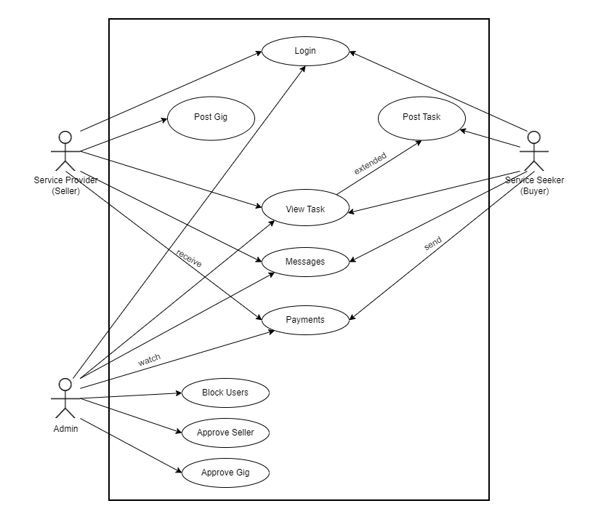

Figure Use Case Diagram



## Expanded Use Case



### Description

Use case diagrams describe the functionality and scope of the system at a high level. These diagrams also identify the interactions between the system and its actors. Use cases and actors in use case diagrams describe what the system does and how the actors use it, but not how the system works internally. A use case diagram shows the different use cases and different types of users a system has and will often be accompanied by other types of diagrams as well. Use cases are represented by either circles or ellipses.

## Activity Diagram

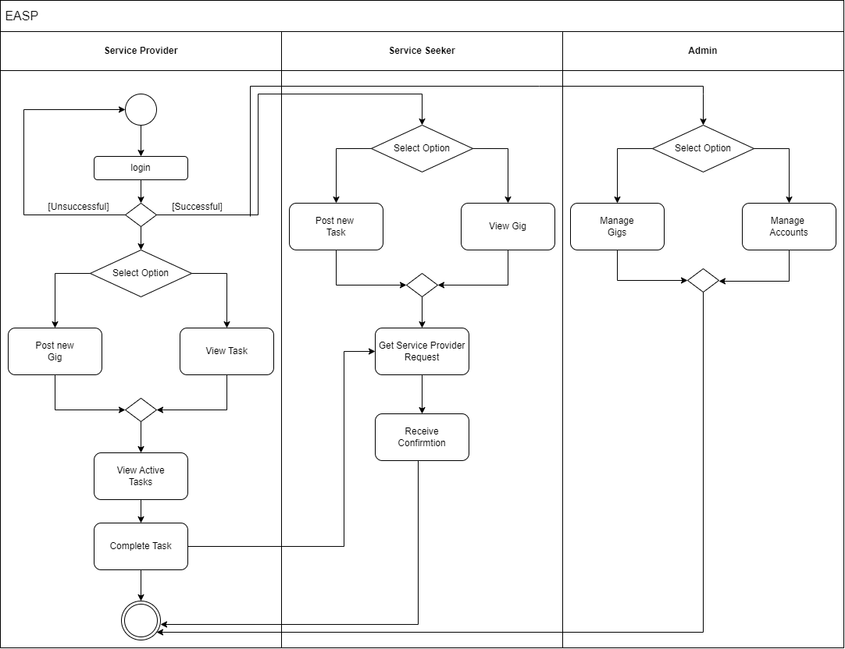

Figure Activity Diagram









### Description

An activity diagram visually represents a series of actions or flow of control in a system similar to a flowchart or data flow diagram. Activity diagrams are often used in business process modeling. They can also describe the steps in a use case diagram. An activity diagram shows the flow of control from the start point to the end point and shows the different decision paths that exist during the execution of the activity.

## Domain Model

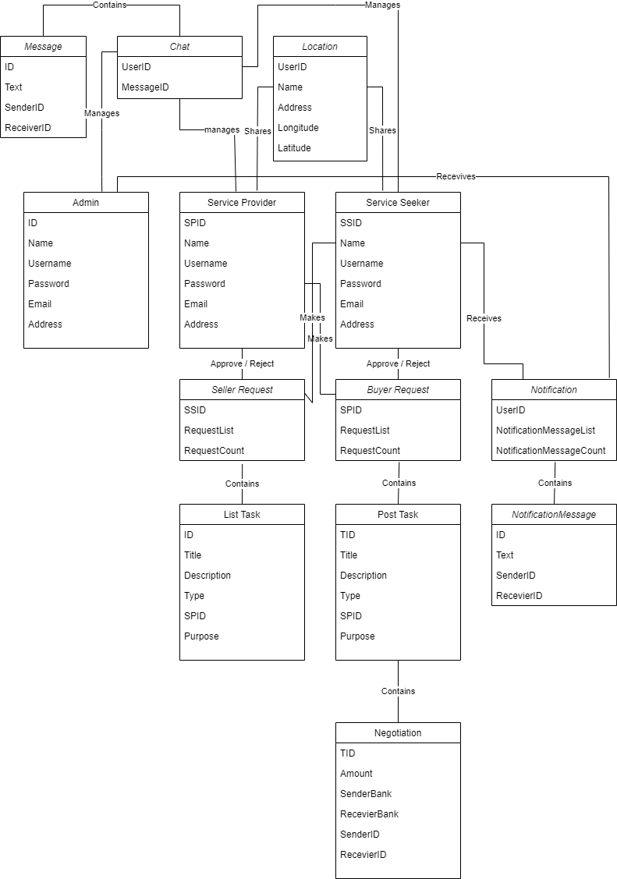

Figure Domain Model



### Description

A domain model contains conceptual classes, associations between conceptual classes, and conceptual class attributes. "Informally, a conceptual class is an idea, thing, or object". The model is displayed as a class diagram. Each class inherits another class. Domain model elements can be added to other diagrams to make them more expressive and to show important information, such as what data is consumed or produced by a business process, or what data is passed between application interfaces.

## Architecture Diagram

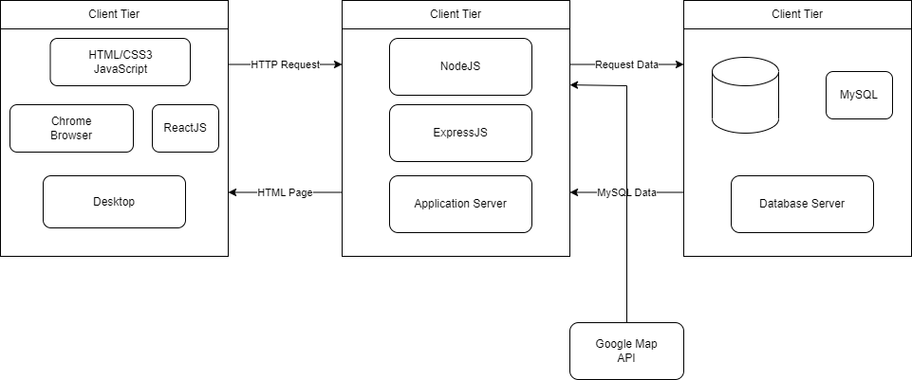

Figure Architecture Diagram



### Description

An architectural diagram is a system diagram used to abstract the overall outline of a software system and the relationships, constraints, and boundaries between components. It is an important tool because it provides an overall view of the physical deployment of a software system and its development plan.

## Sequence Diagram

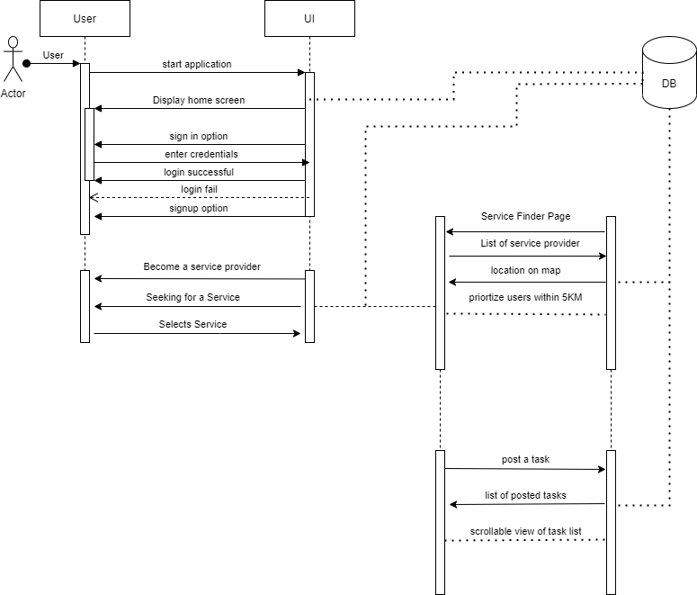

Figure Sequence Diagram



### Description

A sequence diagram consists of a group of objects that are represented by lifelines and the messages they exchange over time during an interaction. A sequence diagram shows the sequence of messages passed between objects. Sequence diagrams can also show control structures between objects. A sequence diagram is a type of interaction diagram because it describes how and in what order a group of objects work together. These diagrams are used by software developers and business professionals to understand the requirements for a new system or to document an existing process.

# Chapter 4: Conclusion

Our vision is to facilitate people and businesses in outsourcing their work; whether you're seeking employment or want a worker to carry out a specific task, we can assist you in finding the best match. As the main theme of this application is to minimize the gap between seekers and service providers, this application will act as a bridge between these entities. This application will act as a bridge between these entities. In the future, as the world is evolving this application will surely be a part of that evolution. And we want a far better outcome as we want our skilled laborer community to have some exposure to a broader audience that will add some additional value to his income and will improve our poverty rate that is going fast as time is passing. Our main theme will be to impact the lives of people who are struggling in life and want to earn some extra, we are a source to them for their betterment. We are hopeful to see this application changing the lives of many people and helping strengthen the economy of our country.

We have gathered all requirements and did our competitive requirements elicitation. We have narrow down our competitor’s problems and we will use them to our advantage. All their missing and best features are a core part of our web application, this can give us an overall edge to our competitors and will help us to grow our project as business in future. All our quality attributes are unique features that those apps don’t have. This is also a competitive advantage to us over them. And our non-functional requirements are better but for best we will try to match our competitors. As our SDLC (Software Development Life Cycle) models allow us to make changes in future and hence we can update some small features through iteration of updates, with Hybrid Software Development Life Cycle we will be able to do these additional updates without increasing development cost as adding one module of extra feature can cost less than writing a full application again if we choose waterfall method. This is how our choice of SDLC is best for our case.

We did research on architectural diagrams of our project on paper to for our future references in phase of development and to guide any layman about our processes so he/she can understand it easily. Each diagram has its own purpose and hence each diagram is to help developer in that phase. For instance, sequence diagram shows how the webapp works in a sequence of manners as a developer made them, meanwhile activity diagram shows that how an activity acts and responds in-case of user actions toward web elements.

# Bibliography

1. Maher, 2020. *Google Play Store.* [Online]   
   Available at: https://play.google.com/store/apps/details?id=com.maharah.vander&hl=en&gl=US  
   [Accessed 15 October 2022].

2. Services Finder, 2018. *Google Play Store.* [Online]   
Available at: https://play.google.com/store/apps/details?id=com.arfatechdevelopers.servicesfinder&hl=en&gl=US  
[Accessed 16 October 2022].

3. SuperTasker.pk, 2019. *Google Play Store.* [Online]   
Available at: https://play.google.com/store/apps/details?id=com.maharah.vander&hl=en&gl=US  
[Accessed 16 October 2022].

4. Wage Indicator, 2019. *Living Wages.* [Online]   
Available at: https://wageindicator.org/salary/living-wage/archive-no-index/pakistan-living-wage-series-september-2019

5. Word Bank, 2022. *Poverty in Pakistan.* [Online]   
Available at: https://www.wionews.com/south-asia/poverty-in-pakistan-up-from-44-to-54-world-bank-393089  
[Accessed 15 November 2022].